**SAT5424 Haritha Aji**

1. Generate Synthea Covid-19 syndromic surveillance disease outbreak HL7 FHIR .json files with the following percentages of each respective hospital population shown below.

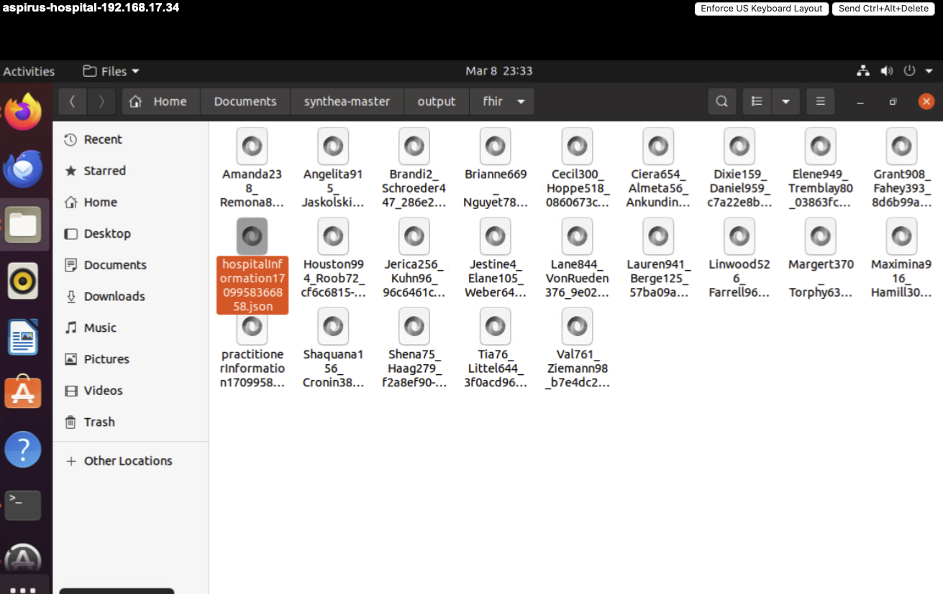

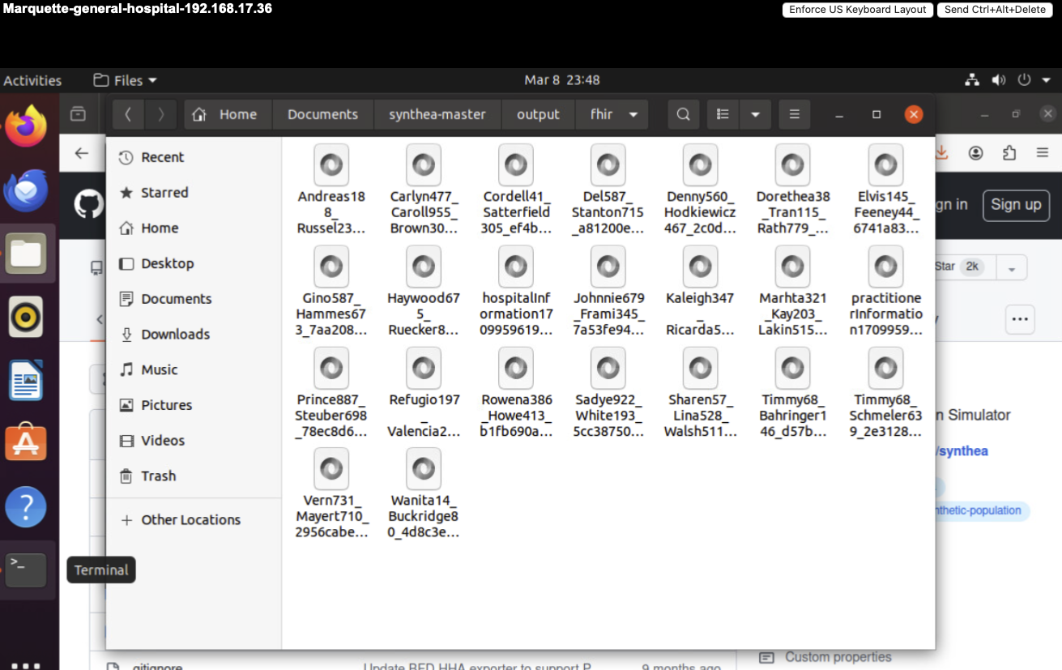

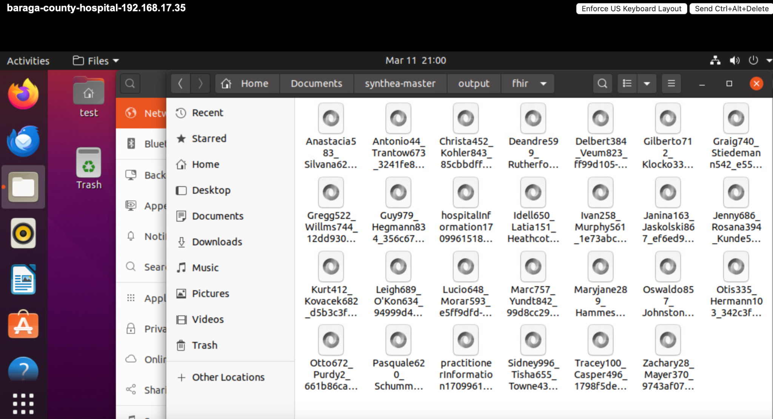

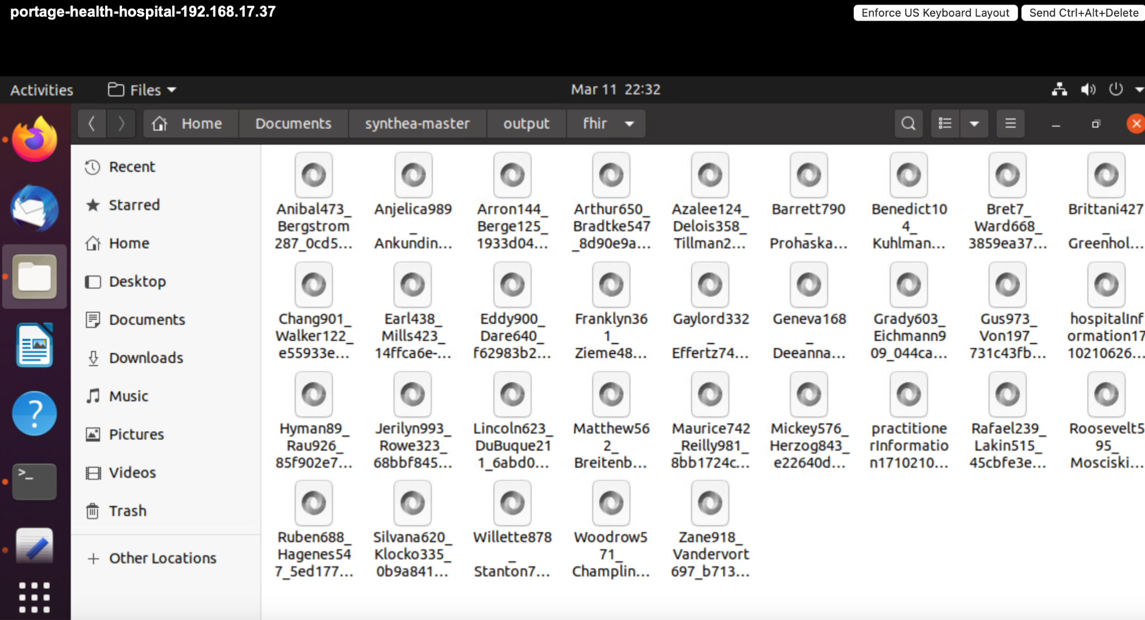

1. Complete the table below (4 points)

| Hospital | % Used of Total Served  Hospital Population | Amount of COVID Patients Created |
| --- | --- | --- |
| Aspirus | <1 | 20 |
| Portage Health | <1 | 20 |
| BCMH | 2 to 4 | 20 |
| MGH | >5 | 20 |

Note: The data created in this assignment will be used in the simulation and visualization of a disease outbreak for a geographic region in the upcoming modules.

1. What was the most challenging portion about this assignment? Why? (4 points)

My Portage Health VM didn’t start up and I was not able to troubleshoot the error. I had to install and set up a new VM. 